Computing list of key figures
Year 1 | Grace Hopper (1906-1992)  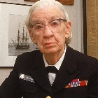  She coined the term ‘bug’ to mean unexplained things going wrong in computing when a moth got into one of the computers she was working on.
Year 2 | Alan Turing (1912-1954)  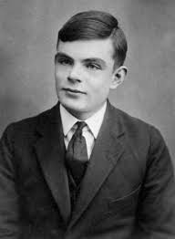  Invented the world’s first computer.
Year 3 | Bill Gates (1955-today)  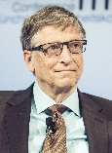  In 1975, American Bill Gates co-founded Microsoft, the PC software company behind ‘Windows’ that was launched in 1985 and used on computers across the world today.
Sir Clive Sinclair (1940-2021)
Sir Clive Sinclair was an inventor and entrepreneur who invented the pocket calculator
Year 4 | Hedy Lamarr (1914-2000)  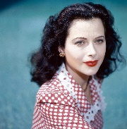  She invented the technology that has enabled us to have Wi-Fi and Bluetooth today
Tim Berners-Lee (1955-Today)
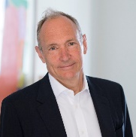
This English man, in 1989, invented the World Wide Web (where the initials ‘www’ come from).

Year 5 | Jack Kilby and Robert Noyce  1923-2005) (1927-1990)  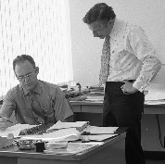  In 1959, while Americans Jack Kilby and Robert Noyce were working for a technology company called Texas Instruments, they patented the pioneering technology that would go on to create the microchip.
Ada Lovelace (1815-1852)
The world’s first computer programmer.
Year 6 | Steve Jobs (1955-2011)  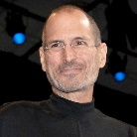  Steve Jobs, along with Steve Wozniak and Ronald Wayne, founded Apple Inc. in a garage in California in 1976.
Mark Zuckerberg (1984-today)
While in his room at Harvard University in America in 2004, Mark Zuckerberg created a place on the Internet for students to link with each other. This has since turned into the giant that is Facebook today.

